IUE Emerging Leader Fellowship 2021
- Online Unification Academy -
The Institute for Unification Education (IUE) of the Ministry of Unification of the Republic of Korea cordially invites junior scholars and professionals who have actively addressed Korean affairs in its Emerging Leaders Fellowship program (ELF). The ELF fellows will take part in virtual unification academy which involves lectures, virtual field trip, research presentation, and webinar.

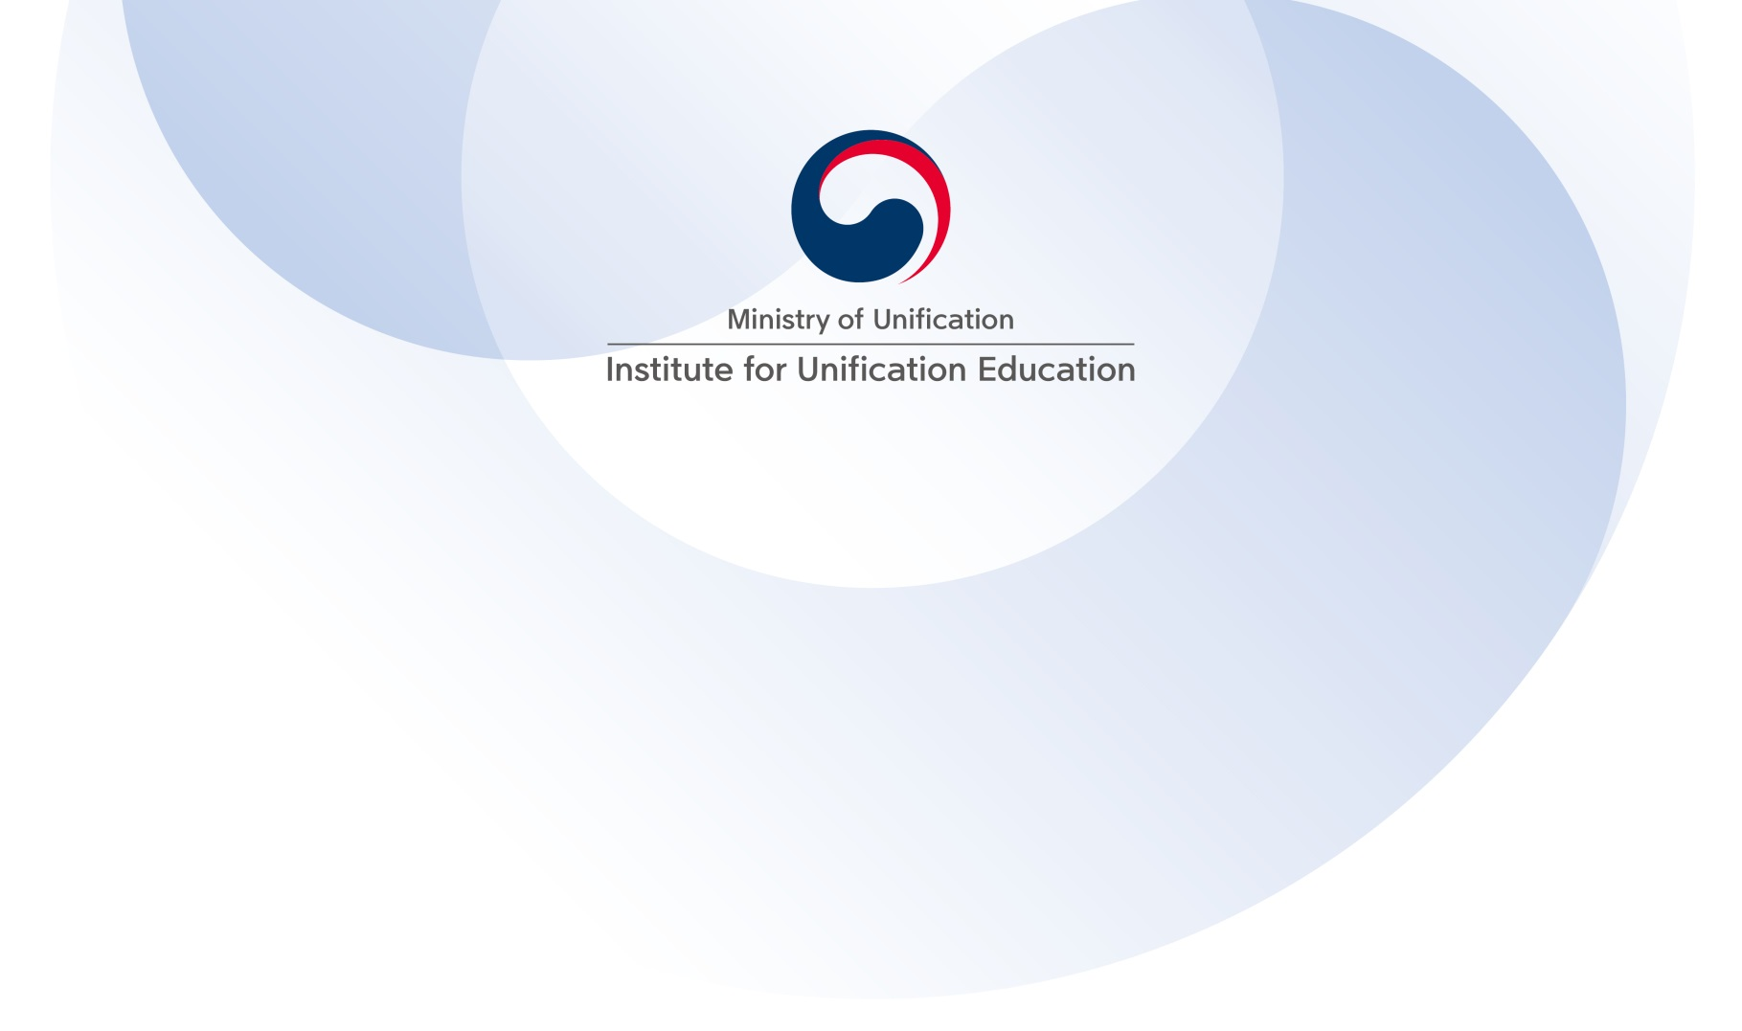
【Objective】

The ELF Fellowship aims to present a unique opportunity to its participants to have and envisage a smarter way of bringing about Korean unification. It also serves as a platform for the participants to create and utilize a working partnership with not only ELF fellows but also many scholars and policy makers in Korea.

【Overview】

- When to take place? June 14 ~16 (3 days)
* Online lectures will be posted (June 1 ~June 13) prior to the unification academy.

(2) How many can participate? This year, IUE invites as many as 20 persons

- What programs to expect?
Online lectures, virtual field trips, research presentation, webinar

<Curriculum>
Lecture  Topics | - ROK’s Unification Policy and Inter-Korean Relations  - Vision for Unified Korea  - Understanding North Korea
Virtual  Field Trip | - DMZ, Panmunjom  - Cultural Tour & Art Performance
Research Presentation | - ELF alumni will present their research on unification issues
Webinar  (June 16) | All participants are strongly encouraged to participate in the full-day Academic Conference either as a presenter or a discussant
【Application Procedure】
Who should apply?

- This fellowship is available for foreign nationals who have sufficient English language skills in order to understand and participate in all aspects of the program.
- Candidates must hold a doctoral degree or demonstrate equivalent academic or professional achievement.

Why become ELF Fellow?

- Presenters and designated discussants at webinar will receive honorarium range from $300~$400. (the amount varies depending the level of commitment)
- Fellows can join a network of 150+ Fellows and partner organizations from across sectors and world regions.

How to apply?

Those who wish to participate in the ELF program must submit followings to globaledu@unikorea.go.kr by April 20, 2021 (Korea Standard Time). Selected ELF fellows will be notified individually via email.

- Application Form and Personal Statement (Attached)
- Copy of Passport
- Copy of degree certificate

Got a question?

Tel: +82 2 901 7036
Email: globaledu@unikorea.go.kr
Address: Institute for Unification Education, 123, 4.19-ro, Gangbuk-gu, Seoul 01018, Republic of Korea

